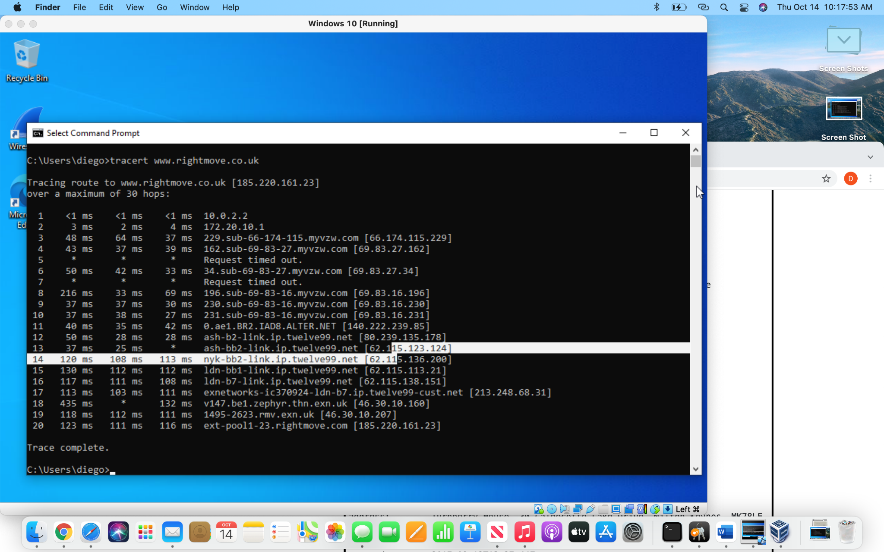

| 3. | 66.174.115.229 | CLLC | Bedminster,NJ |
| --- | --- | --- | --- |
| 4. | 69.83.115.229 | Verizon Wireless | U.S. |
| 6. | 69.83.27.162 | Verizon Wireless | U.S. |
| 8. | 69.83.27.162 | Verizon Wireless | U.S. |
| 9. | 69.83.16.230 | Verizon Wireless | U.S. |
| 10. | 69.83.16.231 | Verizon Wireless | U.S. |
| 11. | 140.222.239.85 | None detected | U.S. |
| 12. | 80.239.135.178 | Telia Company | Sweden |
| 13. | 62.115.123.124 | Telia Company | Sweden |
| 14. | 62.115.136.200 | Telia Company | Sweden |
| 15. | 62.115.113.21 | Telia Company | Sweden |
| 16. | 62.115.138.151 | Telia Company | Sweden |
| 17. | 213.148.68.31 | Turk Ekonomi Bankasi Anonim Sirketi | Turkey |
| 18. | 46.30.10.160 | EX networks limited | United Kingdom |
| 19. | 46.30.10.207 | EX networks limited | United Kingdom |
| 20. | 185.220.161.23 | Right move group Limited | United Kingdom |